HR Salary Dashboard – Train the Dataset and Predict Salary
Project Synopsis
Industrial Training (ECS599)
BACHELOR OF TECHNOLOGY (CSE) (Data Science) (TCS)

PROJECT GUIDE:  Mr Ajay Rastogi | SUBMITTED BY:  Darshil Jain(TCA2365006)

October, 2025



FACULTY OF ENGINEERING & COMPUTING SCIENCES
TEERTHANKER MAHAVEER UNIVERSITY, MORADABAD
Table of Contents

1 Project Title 3
2 Domain 3
3 Problem Statement 3
4 Project Description 3
4.1 Scope of the Work 3
4.2 Project Modules 4
5 Implementation Methodology 4
6 Technologies to be used 6
6.1 Software Platform 6
6.2 Hardware Platform 6
6.3 Tools 6
7 Advantages of this Project 7
Beneficiaries / Target Users 7
8 Future Scope and further enhancement of the Project 7
8.1 Functional Enhancements 8
8.2 Usage and Deployment Enhancements 8
9 Team Details 9
10 Conclusion 9
Main Achievements and Innovations: 9
Project Distinction: 9
11 References 10

Project Title
HR Salary Dashboard – Train the Dataset and Predict Salary

Domain
The project falls under the domain of Human Resource Analytics, utilizing Data Science and Machine Learning techniques to analyze employee data, predict salaries, and provide actionable insights through an interactive dashboard.

Problem Statement
In modern organizations, managing and analyzing large volumes of employee data is a major challenge for HR departments. Manual evaluation of factors like experience, education, and job role often leads to inconsistent and biased salary decisions. This project, “HR Salary Dashboard – Train the Dataset and Predict Salary,” aims to solve this issue by developing a machine learning model that accurately predicts employee salaries based on relevant attributes. The project also includes an interactive dashboard that provides HR professionals with data-driven insights for fair, transparent, and efficient salary management.

Project Description
The project “HR Salary Dashboard – Train the Dataset and Predict Salary” focuses on analyzing employee data to predict salaries using machine learning techniques and visualize the results through an interactive dashboard. It automates salary prediction based on attributes like experience, education, and role, reducing manual errors and improving decision-making in HR processes. The project includes dataset preprocessing, model training, performance evaluation, and dashboard creation for visual insights.
A high-level Context Diagram illustrates the interaction between HR personnel (users), the system (model and dashboard), and the dataset, ensuring smooth data flow and result visualization.

Scope of the Work
What will be done:
- Collection and preprocessing of HR dataset.
- Training machine learning models to predict employee salary.
- Evaluation and comparison of model performance.
- Creation of an interactive dashboard for salary insights.
- Visualization of salary trends and predictions.
What will not be done :
- Real-time data fetching from external HR systems.
- Integration with live organizational payroll software.
- Predicting other HR metrics like attrition or performance.

Project Modules
- Data Collection & Preprocessing Module
Handles importing the dataset, cleaning missing values, encoding categorical variables, and preparing data for analysis.
- Exploratory Data Analysis (EDA) Module
Generates visual insights into features like education, experience, and salary distribution using graphs and charts.
- Model Training & Evaluation Module
Implements machine learning algorithms (e.g., Linear Regression, Decision Tree, Random Forest) to predict salary and evaluates model accuracy.
- Dashboard Module
Displays interactive visualizations and predicted results, allowing HR users to view salary trends, filter data, and compare predictions.
- Result & Insight Module
Summarizes final predictions, highlights key insights, and presents actionable outcomes for HR decision-making.

Implementation Methodology
The proposed system follows a structured approach to develop a data-driven HR salary prediction dashboard. The implementation process begins with data preprocessing, followed by model training and evaluation, and concludes with interactive dashboard creation.
To explain the system workflow, the following diagrams are used:
- Data Flow Diagram (DFD) to represent data movement between processes.
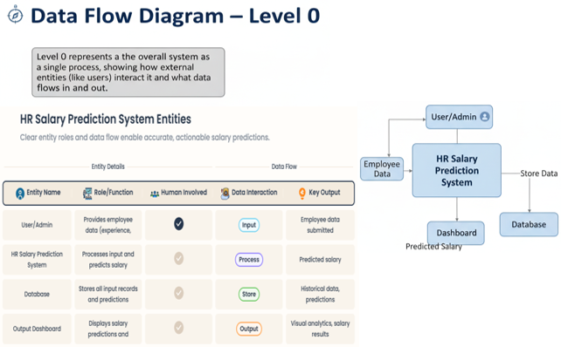
- Entity-Relationship Diagram (ERD) to show database relationships.
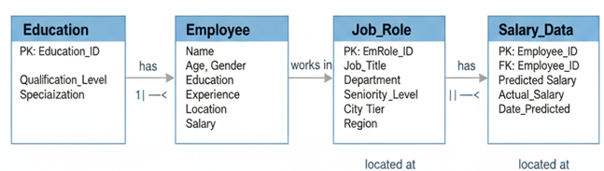
- Use Case Diagram to depict user interactions.
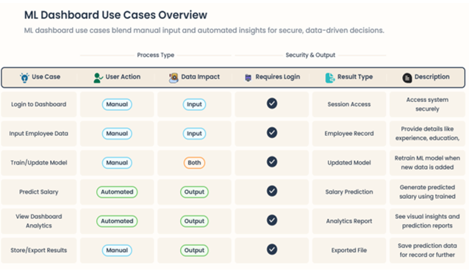
The project will be tested using unit testing for each module and system testing for overall integration. A defect log will be maintained to record, track, and fix any issues identified during the testing phase.

Technologies to be used

Software Platform
- Front-end:
- Streamlit – Used to create an interactive and user-friendly web dashboard for displaying salary predictions and data visualizations.
- Matplotlib / Seaborn / Plotly – Used for generating charts and graphs to visualize trends in employee data.

- Back-end:
- Python – Core programming language used for data preprocessing, model training, and integration with the dashboard.
- Pandas & NumPy – For data manipulation, cleaning, and analysis.
- Scikit-learn – For implementing and training machine learning models (e.g., Linear Regression, Decision Tree).

Hardware Platform
Specification | Description
Processor | Intel Core i3 or higher
RAM | Minimum 8 GB
Hard Disk | Minimum 256 GB
Operating System | Windows 10 / 11 (64-bit)
Editor / IDE | Jupyter Notebook / VS Code
Browser | Google Chrome / Microsoft Edge

Tools
Tool Name | Vendor | Version | Purpose
Python | Python Software Foundation | 3.11+ | Programming, Data Processing, ML Model
Streamlit | Streamlit Inc. | Latest Stable | Dashboard development
Jupyter Notebook | Project Jupyter | 7.0+ | Code testing and visualization
Pandas, NumPy, Scikit-learn | Open Source | Latest Stable | Data processing and machine learning
Matplotlib / Seaborn | Open Source | Latest Stable | Data visualization
Power BI | Microsoft | 2024 | Business intelligence dashboard
Draw.io / Lucidchart | Google / Lucid Software | N/A | Creating ERD, DFD, and flow diagrams

Advantages of this Project
- Accurate Salary Prediction
  - Uses machine learning models to predict fair and data-backed salaries based on employee experience, education, and role.
  - Reduces bias in HR decisions and promotes pay transparency.
- Data-Driven HR Decision Making
  - Helps HR teams analyze trends in salary distribution and workforce data.
  - Enables better budgeting, hiring, and retention strategies.
- Time and Cost Efficiency
  - Automates manual salary analysis that typically requires hours of HR effort.
  - Produces instant results with minimal input.
- User-Friendly Dashboard
  - Provides visual analytics (Power BI / Streamlit) that simplify data interpretation.
  - Even non-technical users can interact with and understand results easily.
- Scalable and Customizable
  - The system can be retrained with new data or adapted to different industries.
  - Future versions can include predictive analytics for promotions or turnover.

Beneficiaries / Target Users
User Group | How They Benefit
HR Managers & Recruiters | Can predict salaries and maintain pay equity.
Organizations | Get accurate compensation insights for workforce planning.
Employees / Job Seekers | Can estimate fair pay based on skills and experience.
Data Analysts | Gain a framework to integrate predictive modeling with business dashboards.

Future Scope and further enhancement of the Project
The current HR Salary Dashboard provides a robust foundation for predictive salary analysis. This section outlines how the project can be significantly enhanced in terms of functionality, usage, and integration to become a more comprehensive HR intelligence tool.

8.1 Functional Enhancements
Area | Enhancement | Benefit
Advanced Predictive Analytics | Introduce Predictive Attrition Modeling and Performance Forecasting alongside salary prediction. | Enables HR to proactively address employee retention risks and identify high-potential employees.
Deep Learning Integration | Use Neural Networks or NLP (Natural Language Processing) to analyze unstructured data (e.g., skill descriptions, performance review text) as input features. | Improves prediction accuracy by capturing nuanced factors not available in structured columns.
Scenario Planning | Implement a "What-If" Analysis Tool in the dashboard, allowing users to adjust input variables (e.g., increase experience by 2 years) and instantly see the predicted salary change. | Supports strategic decision-making in promotion and compensation planning.
Geographic Segmentation | Refine the Location feature using external data to account for Cost of Living Index (COLI) in predictions. | Provides more accurate and fair predictions tailored to specific cities and regions.

8.2 Usage and Deployment Enhancements
- Live System Integration: Integrate the dashboard with actual HRIS (Human Resource Information System) or payroll databases (via APIs) to fetch and train on real-time organizational data.
- User Authentication and Role-Based Access: Implement secure login for HR professionals, granting different access levels (e.g., recruiters see general salary bands; HR managers see precise data).
- Mobile Accessibility: Optimize the web application interface (Flask/Streamlit) for use on mobile devices, allowing HR personnel to access predictions on the go.
- Automatic Retraining Pipeline: Set up an automated MLOps pipeline to periodically retrain and update the model when new salary or employee data becomes available, ensuring the prediction model remains accurate and relevant.
These enhancements transform the project from a standalone predictive tool into a comprehensive and strategic HR Business Intelligence platform.

Team Details
Project Name & ID | Course Name | Student ID | Student Name | Role | Signature
HR Salary Dashboard – Train the Dataset and Predict Salary | Industrial Training (ECS599) | TCA2365006 | Darshil Jain | End-to-End Machine Learning & Dashboard Developer

Conclusion
The HR Salary Dashboard – Train the Dataset and Predict Salary project successfully achieves its objective of providing a robust, data-driven solution for employee compensation analysis.

Main Achievements and Innovations:
- End-to-End Predictive Pipeline: The primary innovation lies in establishing a complete system—from raw data cleaning and advanced Machine Learning (ML) model training (e.g., Random Forest/XGBoost) to the deployment of a user-friendly prediction tool. This moves beyond simple analysis to offer proactive prediction.
- Integration of ML and BI: The project effectively integrates the predictive power of Python-based ML models with the visualization capability of Power BI/Streamlit dashboards. This dual approach allows HR professionals not only to predict salary but also to visualize the underlying trends, promoting transparency and data literacy.
- Enhanced Decision Quality: By basing salary estimations on a data-backed model (accounting for factors like experience, role, and education), the system significantly reduces human bias and inconsistency in compensation decisions, fostering pay equity within the organization.

Project Distinction:
This system stands out by providing an instant, actionable salary prediction via a dedicated web application, combined with comprehensive visual analytics in the dashboard. This unified platform ensures that HR teams can make accurate, defensible, and efficient decisions, positioning the project as a powerful tool for modern Human Resource Management.

References
The following resources, tools, and documentation were referred to during the design, development, and deployment of the HR Salary Dashboard project.
- Kaggle Dataset:
HR Employee Salary Prediction Dataset. Retrieved from https://www.kaggle.com/
- Scikit-learn Documentation:
Machine Learning in Python. Available at https://scikit-learn.org/stable/
- Pandas & NumPy Libraries:
Python Data Analysis Library. Available at https://pandas.pydata.org/
NumPy Documentation. Available at https://numpy.org/
- Matplotlib / Seaborn Libraries:
Data Visualization in Python. Documentation at https://matplotlib.org/
- Streamlit Framework:
Build Data Apps in Python. Retrieved from https://streamlit.io/
- Power BI Documentation:
Create Interactive Dashboards. Available at https://learn.microsoft.com/en-us/power-bi/
- TCS iON RIO-125 Problem Statement:
HR Salary Dashboard – Train the Dataset and Predict Salary. Accessed from TCS iON RIO Project Portal.

LINK TO CODE AND EXECUTABLE FILES
Link to GitHub: -TCS-iON-RIO-125-HR-Salary-Dashboard---Train-the-Dataset-and-Predict-the-Salary-by-TCS-iON
Executable file: http://localhost:8888/notebooks/HR%20Salary%20Prediction-2nd%20Interim.ipynb#

